LOST BIRD
Male Eclectus Parrot

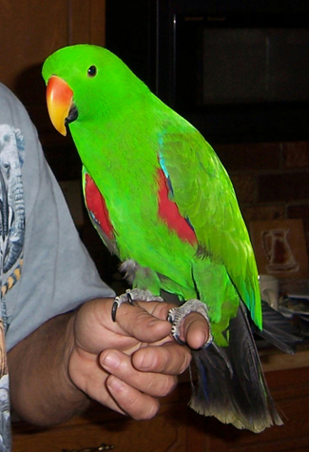
BIRDS NAME
BIRDS DESCRIPTION
LAST SEEN DATE
LAST SEEN LOCATION

PLEASE CALL
YOUR NAME and NUMBER
Flyer template provided by www.goodbirdinc.com

